**What is Azure Virtual Machine**

Azure Virtual Machines (VM) is one of several types of on-demand, scalable computing resources that Azure offers. Typically, you choose a VM when you need more control over the computing environment than the other choices offer. This article gives you information about what you should consider before you create a VM, how you create it, and how to connect to it.

An Azure VM gives you the flexibility of virtualization without having to buy and maintain the physical hardware that runs it. However, you still need to maintain the VM by performing tasks, such as configuring, scale-up/down the machine, and installing the software that runs on it.

Azure virtual machines can be used in various ways. Some examples are:

* **Development and test** – Azure VMs offer a quick and easy way to create a computer with specific configurations required to code and test an application.
* **Applications in the cloud** – Because demand for your application can fluctuate, it might make economic sense to run it on a VM in Azure. You pay for extra VMs when you need them and shut them down when you don’t.
* **Extended datacenter** – Virtual machines in an Azure virtual network can easily be connected to your organization’s network.

The number of VMs that your application uses can scale up and out to whatever is required to meet your needs.

**Prerequisites**

* An Azure Cloud Account ( you can learn how to create one from our previous blog [**here**](https://k21academy.com/microsoft-azure/create-free-microsoft-azure-trial-account/).)
* Access to an SSH client: for this tutorial, we will be using Putty and Putty Key Generator installed on our Windows computer for accessing our Ubuntu Virtual Machine.

**Creating An Ubuntu Virtual Machine**

**Step 1:**In the [**Azure portal**](https://portal.azure.com/), search for Virtual Machine and select **Virtual Machine**.

***Note:***Please make sure you have a subscription before doing all this. If you created a free account for the first time, you’ll already have a FREE TRIAL subscription for 1 month.

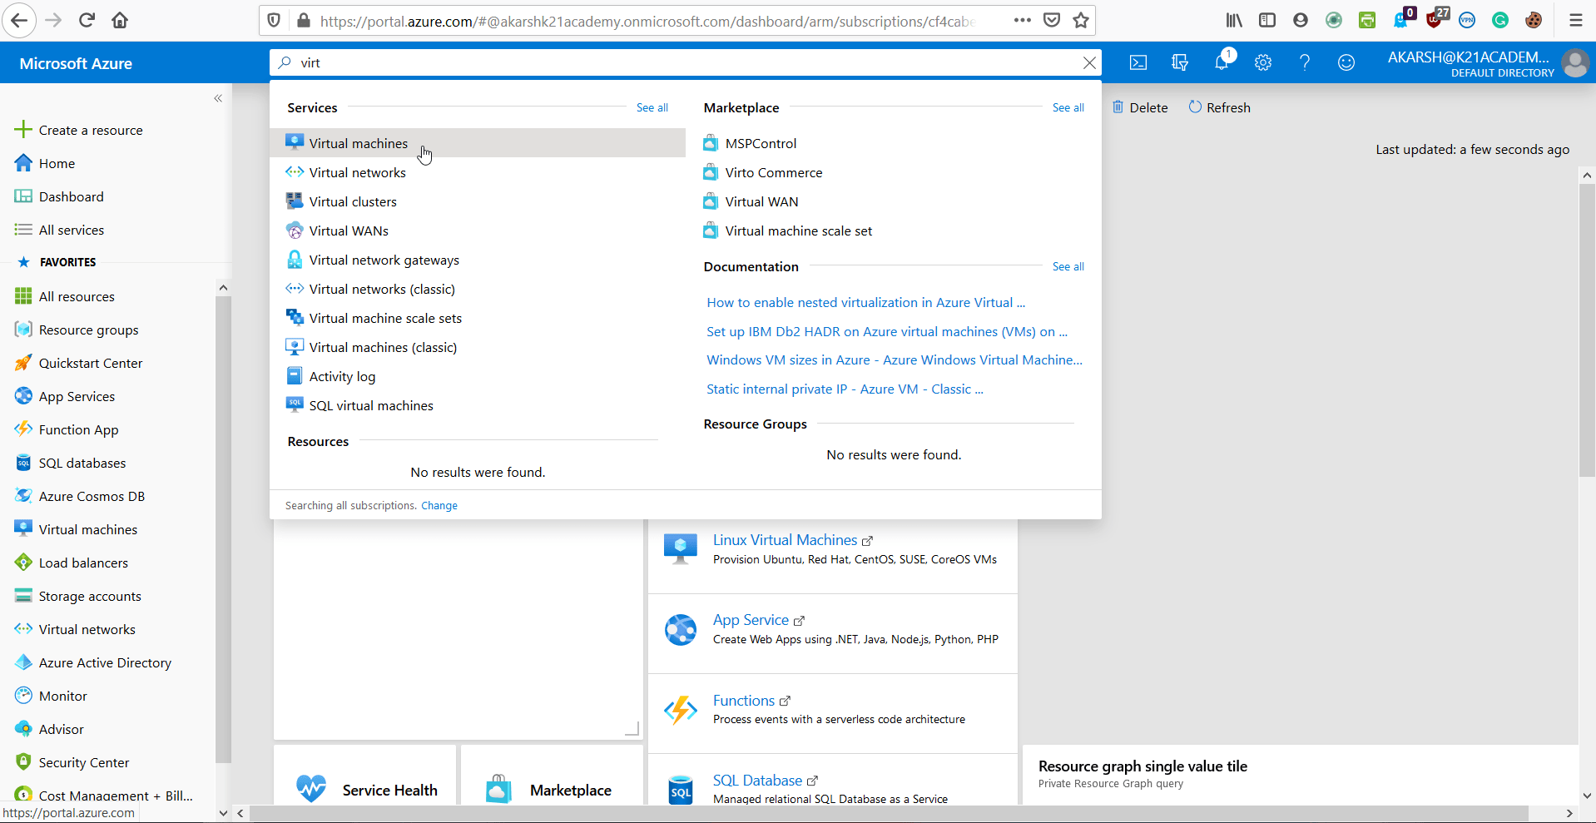

**Step 2:**Select **Add.**

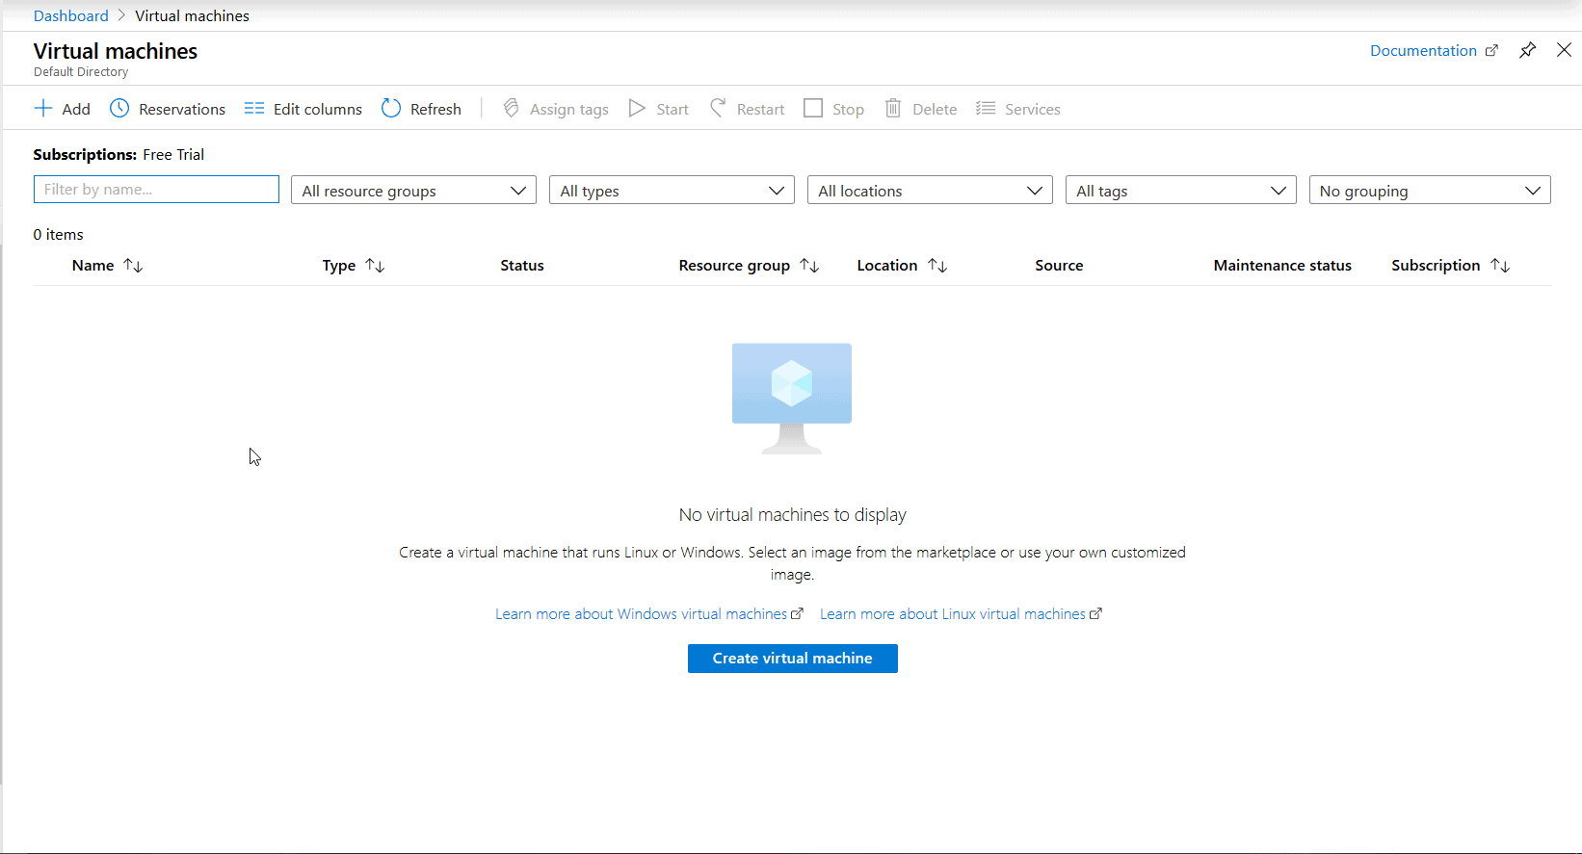

**Also Check:**Our blog post on [**Azure Blob Storage**](https://k21academy.com/microsoft-azure/az-104/azure-blob-storage/). Click here

**Step 3:**Enter the following values:

1. **Subscription**: Select your Azure subscription.
2. **Resource group**: Enter a new resource group name.
3. **Virtual Machine name**: It should be a **unique** name throughout the Azure network.
4. **Region**: Select an Azure location, such as **Western India, Central US, etc**.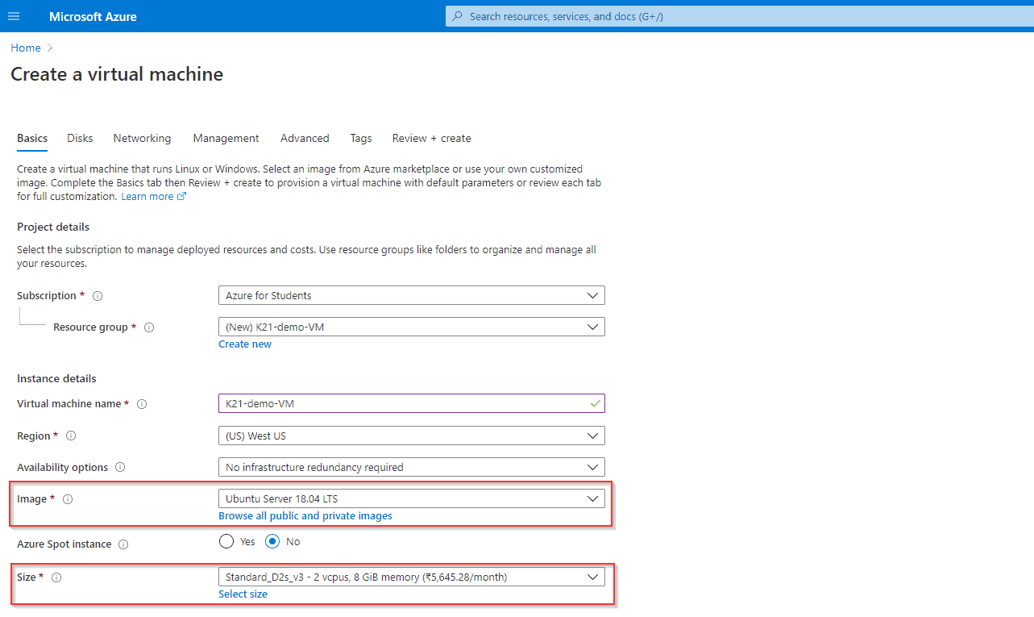
5. **Authentication Type:**SSH Public Key
6. **SSH Public Key Source:**Generate new key pair
7. **Select Inbound Ports:**SSH (**22**), this is the port that we will be using to connect to our Virtual Ubuntu Machine.

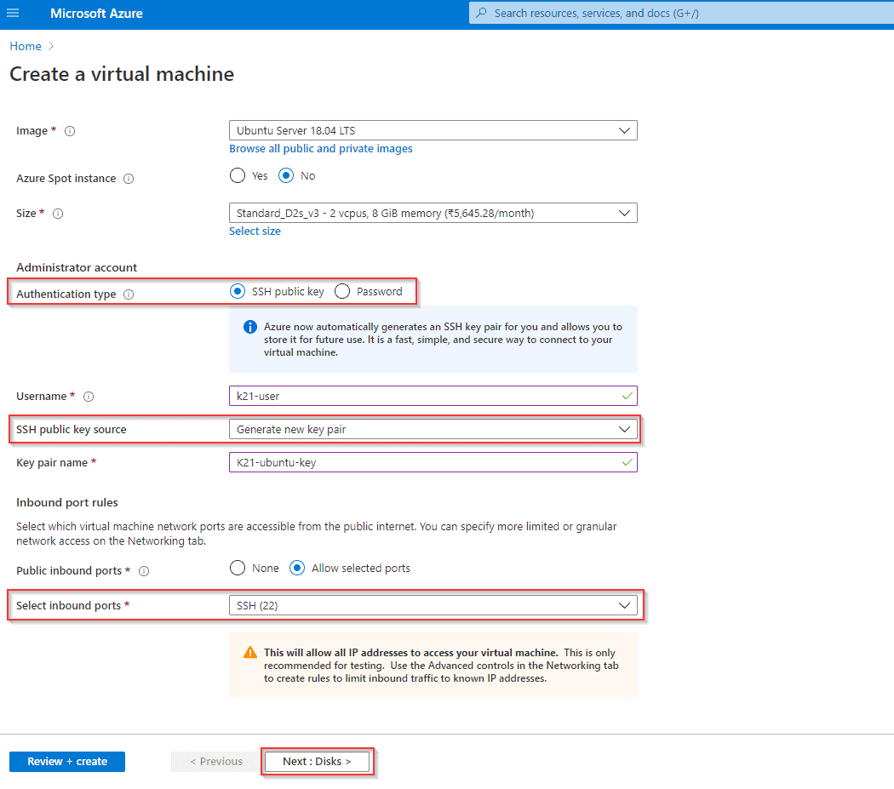

1. Select the Username and Key name as required and note them down as **we will need them later.**
2. Once done, click on Next: Disks >

**Also Check:**Step by Step Instructions to install [**Azure Powershell**](https://k21academy.com/microsoft-azure/az-104/azure-powershell-module-guide/) Module. Click here

**Step 4:**Select the type of disk you want to use. Click Next.

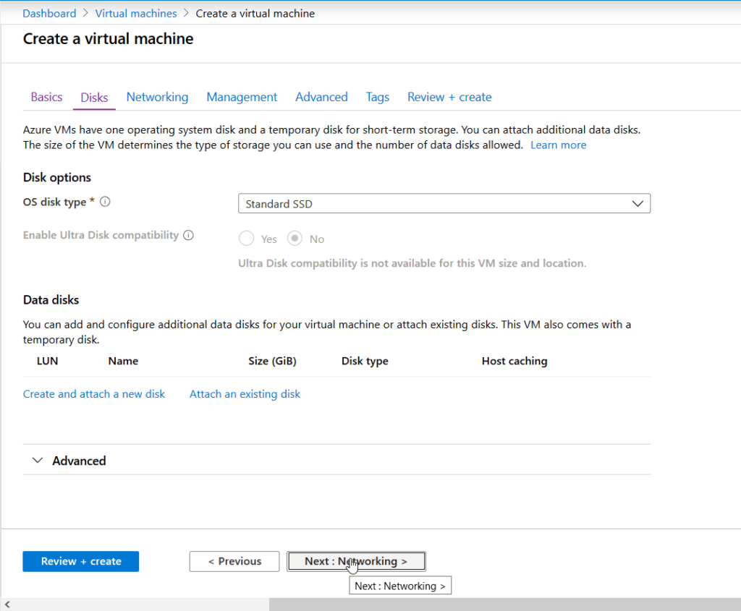

**Check Out:**[What is Azure Availability Zone](https://k21academy.com/microsoft-azure/az-104/az-104-region-availability-zone-availability-sets-and-fault-domainupdate-domain-in-microsoft-azure/)? Click here

**Step 5:**Configure Networking

1. **Virtual Network:**Create a new one or use your existing Network.
2. **Select Inbound Ports:** SSH(22), This allows Port 22 to be opened in your Virtual Network for incoming traffic and will enable us to connect to our Virtual Machine inside our Virtual Network.
3. Leave everything else as default and click **next** to go to the Management Section.

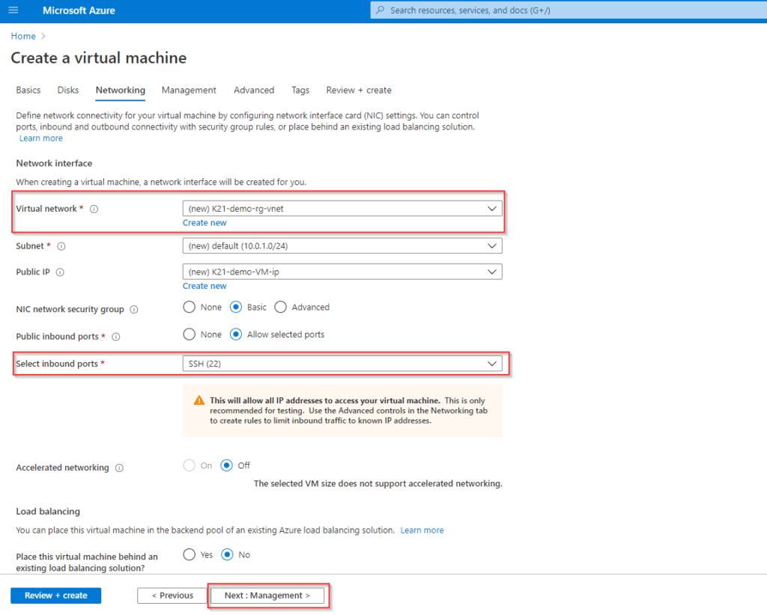

**Also Read:**Our previous blog post on [Azure Kubernetes Service](https://k21academy.com/microsoft-azure/az-104/video-containers-docker-kubernetes-in-azure-for-beginners/). Click here

**Step 6:**Management

Leave all options as default and click on **next** to go to the Advanced Section.

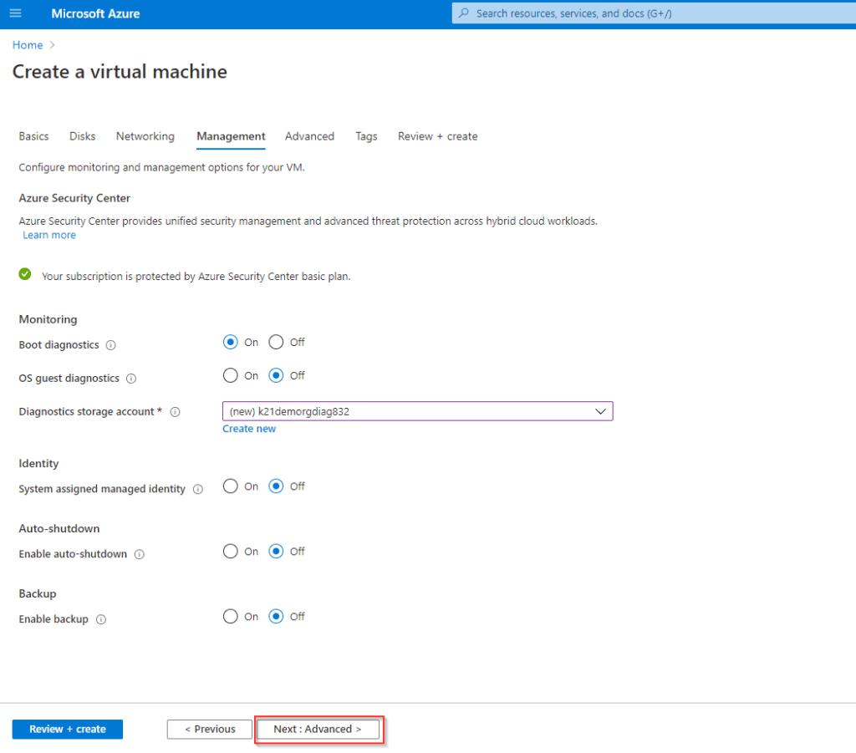

**Step 7:**Advanced Configuration

Add any custom data you want to run when the VM is being created or leave all options as default and click on **next** to go to the Tags Section.

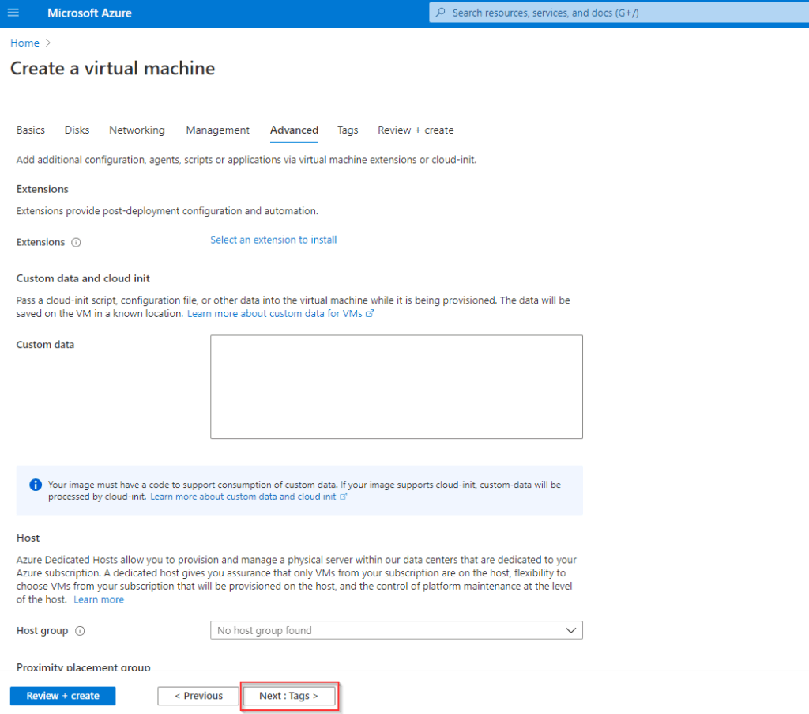

**Also Read:**Our previous blog post on [**VM Scale Set Azure**](https://k21academy.com/microsoft-azure/az-104/virtual-machine-scale-set-in-microsoft-azure/). Click here

**Step 8:**Tags Configuration

Add any descriptive tags you would like to put to identify your VM at a later stage or leave Options at default and click on **next** to review and create your Virtual Machine.

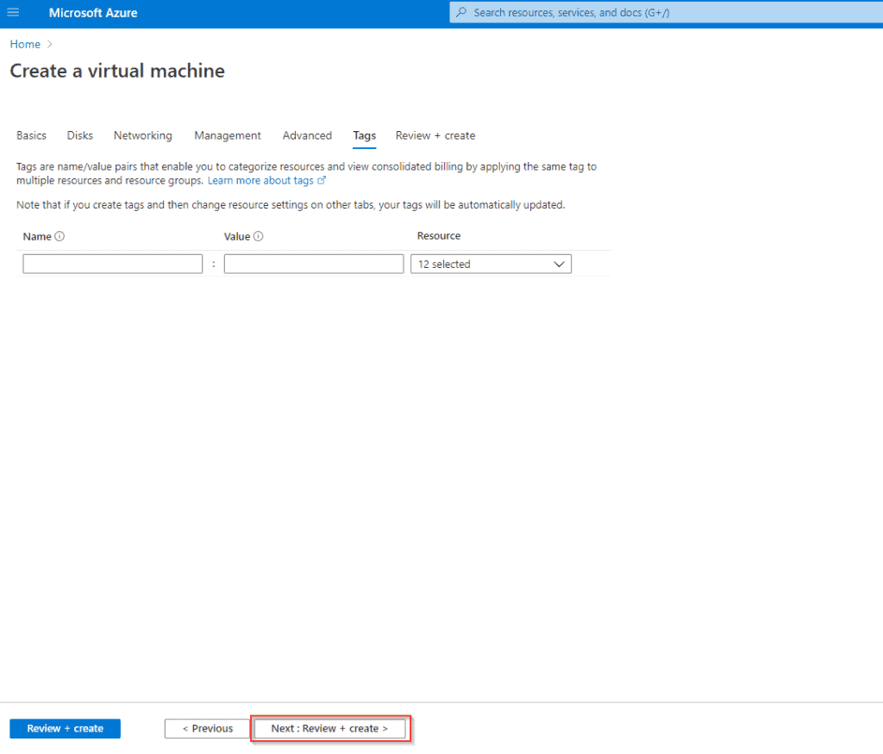

**Step 9:**Review your settings and make any changes if required and select **Create**. It takes a few seconds to create a VM.

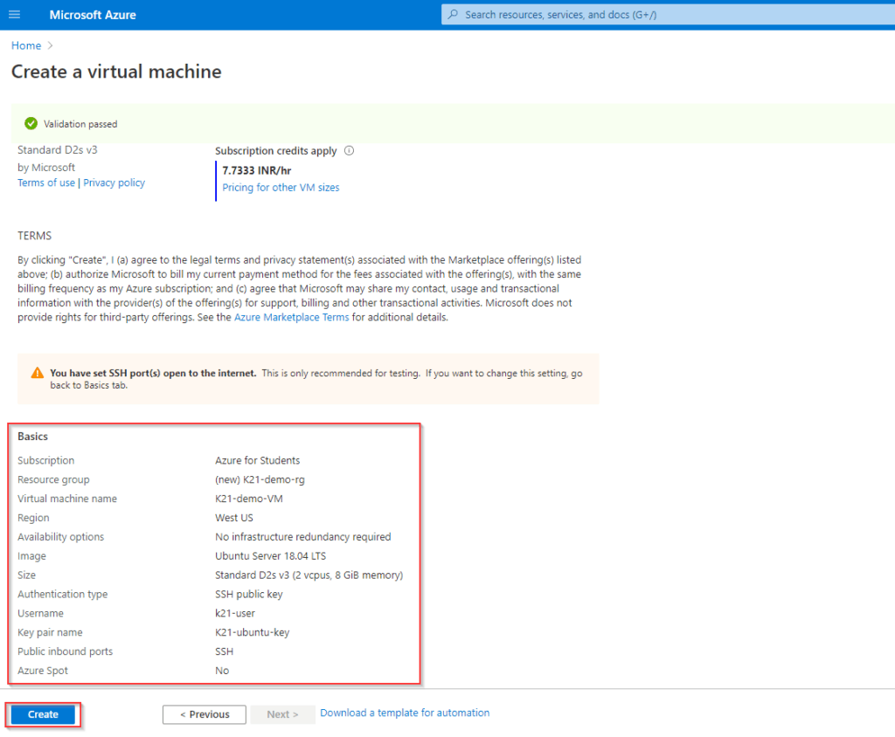

**Also Read:**[Azure Application Gateway vs Front Door](https://k21academy.com/microsoft-azure/az-104/azure-front-door-vs-application-gateway-vs-load-balancer/): know their major differences!

**Step 10:**SSH Keys

1. After you click on Create Azure will create an SSH Key Pair that we will be using to connect to our VM later. **Make sure to download the private key and keep it somewhere safe.**
2. Azure **does not**store your private key and this is the **only** instance when you will be able to access your private key from Azure.

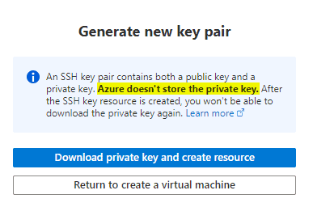

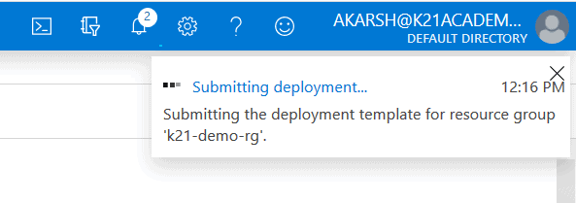

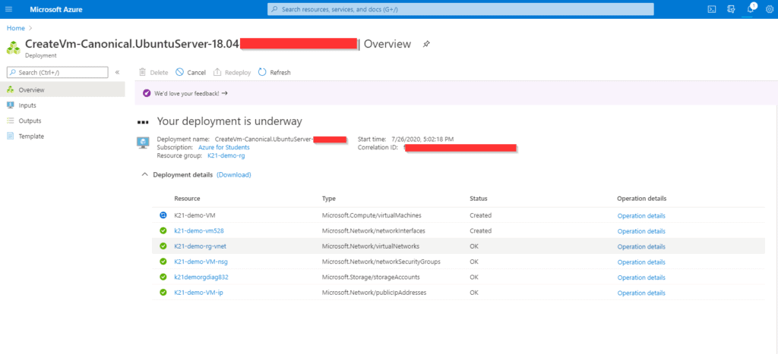

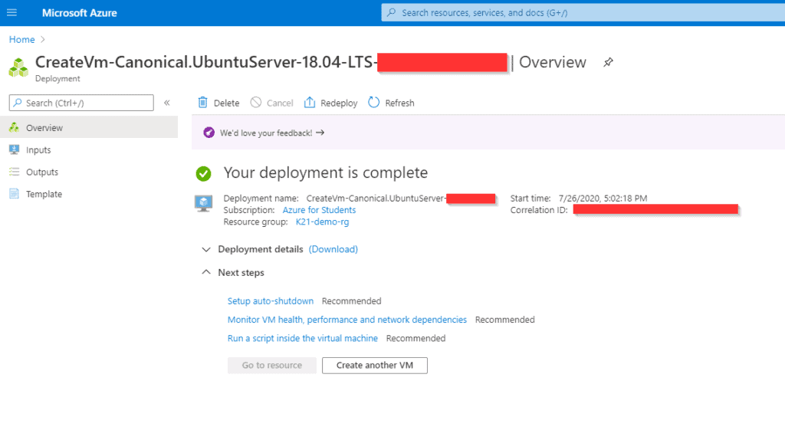

**Also Read:**What are the roles and responsibilities of an[**Azure Administrator Associate**](https://k21academy.com/microsoft-azure/az-104/az-104-roles-and-responsibilities-as-a-microsoft-azure-administrator/)**.**Click here

**Connecting to Ubuntu Virtual Machine**

As we have configured our VM to be accessible via SSH we will be using the PuTTY SSH client on our Windows machine.

You can download and install PuTTY from its [**official**](https://www.putty.org/) website. Simply select Download Putty and choose the appropriate installation file (32-bit or 64-bit as per your system) from the choices shown.

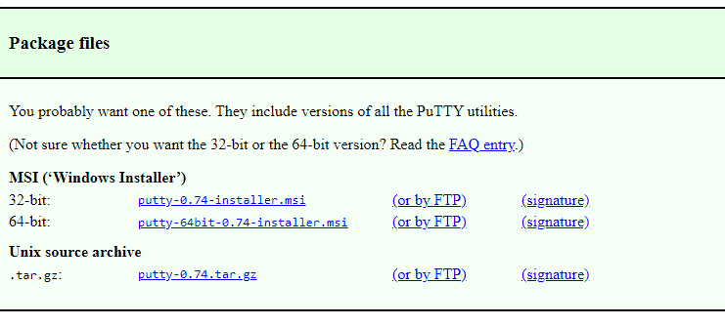

**Step 1:**Converting our Private key into the proper extension.

The Azure private key we downloaded is in the (**.pem**) format, for using it with PuTTY we need to convert it into the (**.ppk)**format.

1. Open PuTTYgen, an application automatically installed alongside PuTTY.
2. Select load an **existing**private key. (make sure to select **All files** option while browsing to your [**Azure Key**](https://k21academy.com/microsoft-azure/az-104/az-104-create-and-connect-an-ubuntu-virtual-machine-in-azure/#Step_10))
3. You will get an Operation successful message if the key was imported correctly.
4. Click on **Save Private Key**to save the key in a PuTTY usable format.
5. you can optionally set a password to be used with this key for further security but for this tutorial, we will be skipping that.

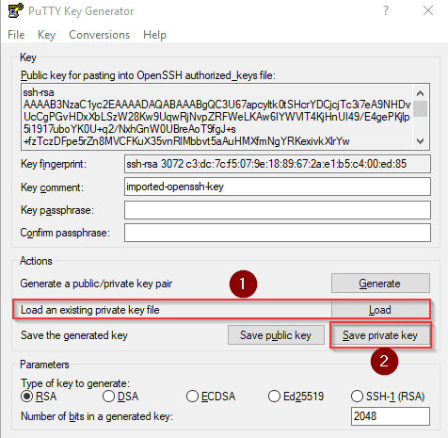

**Also Check:**[Az 104 Microsoft Azure Administrator](https://k21academy.com/microsoft-azure/az-104/az-104-microsoft-azure-administrator-certification/): PDF Documentation & Tutorial. Click here

**Step 2:**Getting the SSH connection information.

1. Go to the VM dashboard
2. Select your VM
3. Note the **public IP address.**

***Note:***every time the VM is restarted, this IP will be **Different,**unless you have an **Elastic IP**configured for your VM.

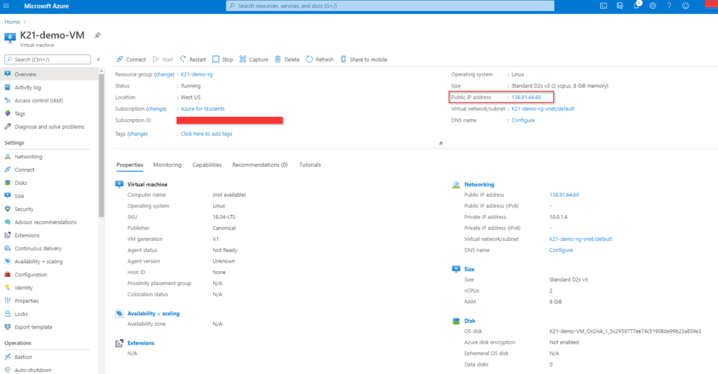

**Also Read:**Our blog post on [Vnet Peering Azure](https://k21academy.com/microsoft-azure/az-104/virtual-network-vnet-peering-in-azure/). Click here

**Step 3:**Open the PuTTY installation on your Windows Machine.

1. Enter the Host Name details in the following format: <**Username of VM**>@<**Public IP of VM**>
2. Make sure Port is **22.**
3. The connection type is **SSH.**

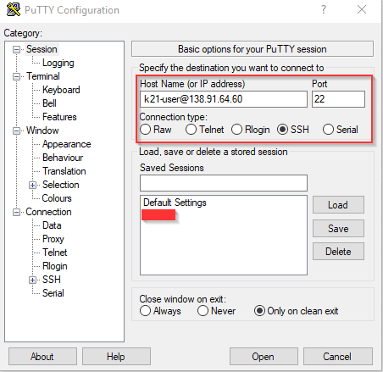

**Also Check** [az 104 vs az 103](https://k21academy.com/microsoft-azure/az-104/az-104-v-s-az-103-microsoft-azure-certification-exam/): to know the major differences between them.

**Step 4:**Inserting our SSH key for authentication.

1. Expand the **SSH** option under Connection in the sidebar.
2. Select **Auth, Do not expand it.**
3. Leave all options at default settings and under private key file for authentication, browse to the **Private Key**we had[**created from PuTTYgen**](https://k21academy.com/microsoft-azure/az-104/az-104-create-and-connect-an-ubuntu-virtual-machine-in-azure/#Save_Private_Key) earlier.
4. Click Open.
5. Click yes in the security alert box to allow the remote connection.

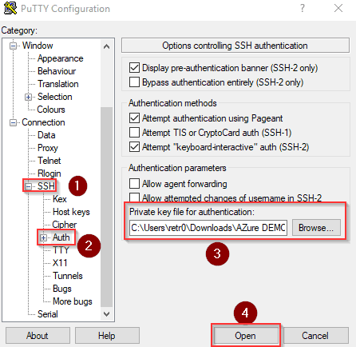

If all the steps were done correctly then the connection will be successful and you will be logged into your Ubuntu Virtual Machine.

